Lab Exercise 5- Generate and Use SSH Key with Git and GitHub
Objective:
To learn how to generate an SSH key, add it to GitHub, and use it to securely connect and push code without repeatedly entering a password.

Prerequisites
- Git installed on your local machine
- GitHub account
- Basic understanding of Git commands

Step 1 – Check for Existing SSH Keys
Run:
ls -al ~/.ssh
Look for files like id_rsa and id_rsa.pub. If they exist, you may already have an SSH key.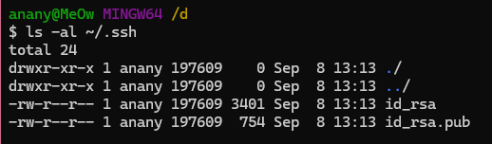

Step 2 – Generate a New SSH Key
Run:
ssh-keygen -t rsa -b 4096 -C "your_email@example.com"
- -t rsa → key type
- -b 4096 → key length
- -C → comment (your GitHub email)
When prompted:
- Press Enter to save in the default location: /home/user/.ssh/id_rsa (Linux/Mac) or C:\Users\<username>\.ssh\id_rsa (Windows)
- Optionally, set a passphrase for extra se 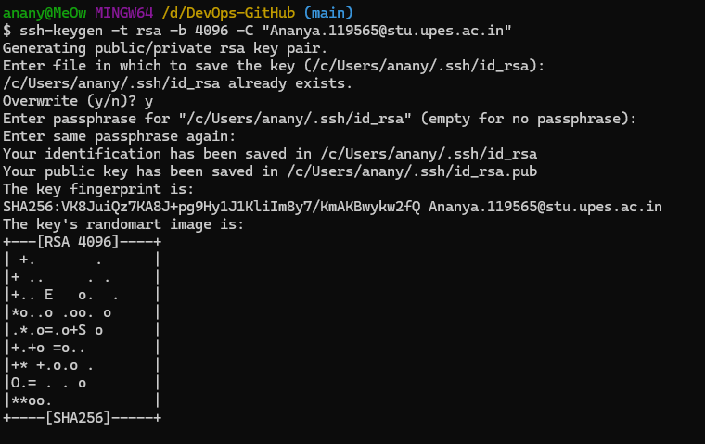

Step 3 – Start the SSH Agent
eval "$(ssh-agent -s)"

Step 4 – Add SSH Key to the Agent
ssh-add ~/.ssh/id_rsa
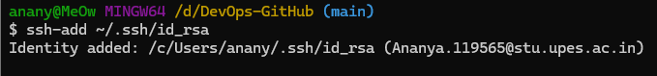
Step 5 – Add SSH Key to GitHub
- Copy the public key:
cat ~/.ssh/id_rsa.pub
- Log in to GitHub → Settings → SSH and GPG Keys → New SSH key.
- Paste the key and save.
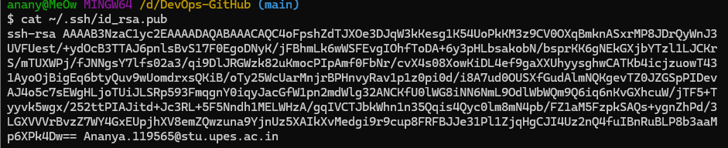

Step 6 – Test SSH Connection
ssh -T git@github.com
Expected output:
Hi <username>! You've successfully authenticated, but GitHub does not provide shell access.
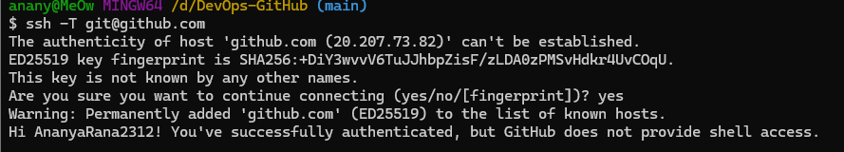
Step 7 – Use SSH to Clone a Repository
git clone git@github.com:<username>/<repository>.git
Now you can pull and push without entering your username/password.
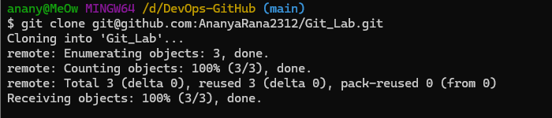

Use Case
Scenario:
An organization’s developers often need to push code to GitHub multiple times a day. Using SSH keys eliminates the need to repeatedly enter credentials, while maintaining secure, encrypted communication between the developer’s machine and GitHub.

Table – HTTPS vs SSH for GitHub
Feature | HTTPS | SSH
Authentication | Username & password / token | SSH key pair
Convenience | Requires login each session | No password once key is added
Security | Encrypted, but password-based auth | Encrypted, key-based authentication
Best For | Occasional access | Frequent development work

